12.40 ENGAGEMENT QUALITY REVIEW – PLANNING (AUDIT)

The following describes the functionality and features included in Probe Audit Premium+

Objective

The objective of this document is to document the engagement quality review procedures performed during the planning phase of the audit, including the eligibility and declaration of the engagement quality reviewer, inspection of firm policies and procedures, gathering of information, evaluation of significant judgments and matters, and the engagement quality reviewer's conclusion.

The following key concepts of the Probe Audit Premium+ Methodology are set in this document:
- Early independent oversight of the engagement through planning-stage quality review (ISQM 2)
- Evaluation of the engagement team’s risk assessments and overall audit strategy
- Opportunity for course correction of the engagement approach before significant procedures are performed

Document placement

Document 12.40 – Engagement quality review – Planning (Audit) can be found in the Audit planning folder in the Caseware document manager.
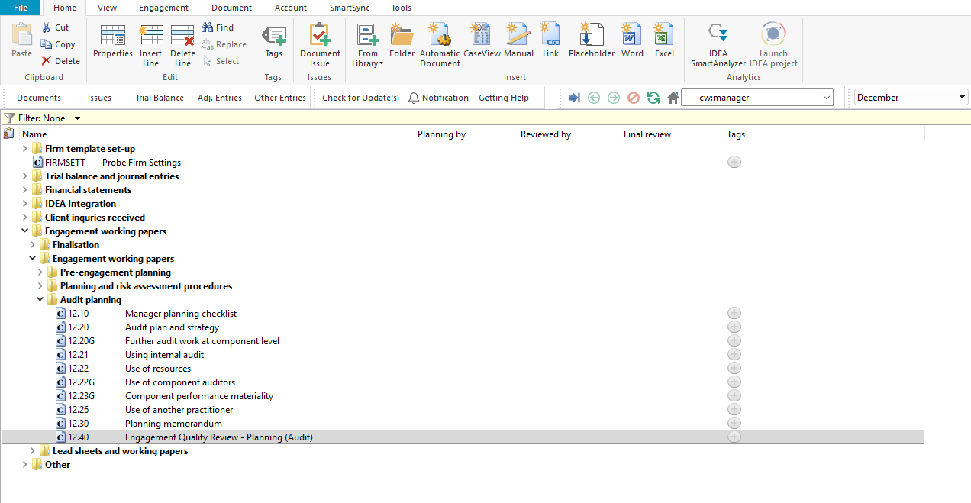

Document content

This document is designed to be a questionnaire and checklist type document with space for a comment or further description.

The document addresses the requirements of ISQM 2 – Engagement Quality Reviews and ISA 220 (Revised) – Quality Management for an Audit of Financial Statements. It covers the engagement quality review team composition, the engagement quality reviewer's declaration and eligibility, firm policies and procedures, gathering of information, evaluation of significant judgments and matters, and the engagement quality reviewer's conclusion on the planning phase.

This document is divided into different bookmarks in the document map to assist you in documenting the engagement quality review during planning:

Engagement quality review team

Engagement quality reviewers declaration

Firm policies or procedures

Eligibility as EQ Reviewer

Gathering information

Significant judgments and matters

Firm mandatory – based on events and conditions present

Conclusion

Engagement quality reviewer
[Screenshot: Document map]

Layout
Column | Input Required | Outcome
Engagement quality review team
Question | No input is required in this column. Read the question relating to the engagement quality review team. | No impact on the engagement file.
Ref. | Record a reference to supporting documentation. | No impact on the engagement file.
Detail | Provide details supporting the answer to the question. | No impact on the engagement file.
Yes / No | Select Yes or No to the question. | No impact on the engagement file.
Engagement quality reviewers declaration
Declaration | No input is required in this column. Read the declaration text and the considerations listed that may impair eligibility as engagement quality reviewer. | No impact on the engagement file.
Signature table | Complete the engagement quality review team member details including name, qualification, role, experience as engagement quality reviewer, industry experience, engagement experience, and sign the declaration with a signature and date. | No impact on the engagement file.
Firm policies or procedures
Question | No input is required in this column. Read the questions relating to the inspection of the firm's SoQM policies and procedures. | No impact on the engagement file.
Ref. | Record a reference to supporting documentation. | No impact on the engagement file.
Detail | Provide details of the inspection performed on the firm's policies and procedures. | No impact on the engagement file.
Yes / No | Select Yes or No to the question. | No impact on the engagement file.
Eligibility as EQ Reviewer
Question | No input is required in this column. Read the questions relating to the eligibility of the engagement quality reviewer. | No impact on the engagement file.
Ref. | Record a reference to supporting documentation. | No impact on the engagement file.
Detail | Provide details supporting the eligibility confirmation. | No impact on the engagement file.
Yes / No | Select Yes or No to the question. | No impact on the engagement file.
Gathering information
Question | No input is required in this column. Read the questions relating to information gathered by the engagement quality reviewer. | No impact on the engagement file.
Ref. | Record a reference to supporting documentation. | No impact on the engagement file.
Detail | Provide details of the information gathered and discussions held with the engagement partner and engagement team. | No impact on the engagement file.
Yes / No | Select Yes or No to the question. | No impact on the engagement file.
Significant judgments and matters
Question / Consideration | No input is required in this column. Read the questions and considerations relating to significant judgments made by the engagement team in planning. | No impact on the engagement file.
Ref. / Performed by | Record a reference to supporting documentation. For certain considerations, record the name of the person who performed the procedure. | No impact on the engagement file.
Detail | Provide details of the review performed and the evaluation of significant judgments. | No impact on the engagement file.
Yes / No | Select Yes or No to the question or consideration. | No impact on the engagement file.
Firm mandatory – based on events and conditions present
Ref. | Record a reference to supporting documentation for the firm mandatory procedures. | No impact on the engagement file.
Detail | Provide details of the firm mandatory procedures based on events and conditions present. | No impact on the engagement file.
Yes / No | Select Yes or No to confirm the firm mandatory procedure. | No impact on the engagement file.
Conclusion
Question | No input is required in this column. Read the questions relating to the engagement quality reviewer's conclusion on the planning phase. | No impact on the engagement file.
Ref. | Record a reference to supporting documentation. | No impact on the engagement file.
Detail | Provide details supporting the conclusion reached by the engagement quality reviewer. | No impact on the engagement file.
Yes / No | Select Yes or No to the question. | No impact on the engagement file.
Engagement quality reviewer
Engagement quality reviewer sign-off | Complete the engagement quality reviewer sign-off with a comment, name, signature and date. | No impact on the engagement file.

Document outcomes

The engagement quality review team section must be completed to confirm whether the engagement quality reviewer plans to use assistants to perform the engagement quality review.

The engagement quality reviewers declaration must be completed to confirm that no circumstances impair the eligibility of the engagement quality reviewer, including independence and objectivity. The signature table must be completed with the team member details.

The firm policies or procedures section must be completed to confirm that the firm's SoQM policies and procedures related to engagement quality reviews have been inspected.

The eligibility section must be completed to confirm that no law, regulation or circumstances impair the eligibility of the engagement quality reviewer.

The gathering information section must be completed to document the information obtained and discussions held with the engagement partner and engagement team regarding significant judgments and matters in planning.

The significant judgments and matters section must be completed to document the review and evaluation of significant judgments made by the engagement team in planning, including the appropriateness of the basis, professional skepticism applied, and conclusions reached.

The conclusion section must be completed to confirm that the planned procedures will provide a sufficient basis to perform an objective evaluation of the significant judgments made by the engagement team and the conclusions reached.

The engagement quality reviewer sign-off must be completed with a comment, name, signature and date.

Group Audits

When the engagement type was selected as 'Group Audit Single' or 'Group Audit Multiple', questions are modified for the separate group audit engagement file.

Additional questions were added for group audit engagement to:

Identify components for planning and performing of audit procedures;

Determine expected involvement of component auditors in risk assessment procedures and further audit procedures;

Evaluate access to components and component auditors; and

Determine whether there is any indication that the group auditor will not be able to be sufficiently and appropriately involved in the work of the component auditor.

Some questions include red warnings or blue text in the description column. Follow the red warnings that inform you where key information should be recorded and the blue text in the description column that advises you where the understanding may be documented.

IN CONCLUSION

Features

The following features are available in the document:

Insert or delete a comment, see page F3

Insert or delete a row, see page F5

Guidance, see page F16

Freeze, see page F19

